AP Biology Summer Reading Guide 2013 -2014

The following are questions covering the most important information that you need to be exposed to prior to class starting next year. They are pulled from reading guides that you will get on each chapter we will cover. The purpose of this is to expose you to some of the most important topics early. That way when we covering them in full you won’t be totally overwhelmed.

Use your textbook to answer these questions from the indicated chapters. You can do this by hand or you can type the answers and save them electronically in the Dropbox account I have set up for you.

Chapter 3: Water and the Fitness of the Environment

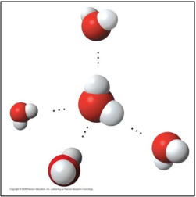
Concept 3.1 The polarity of water molecules results in
hydrogen bonding

Study the water molecules at the right. On the central
molecule, label oxygen (O) and hydrogen (H).

- What is a polar molecule? Why is water considered polar?

- Now, add + and – signs to indicate the charged regions of each molecule. Then, indicate the hydrogen bonds.

- Explain hydrogen bonding. How many hydrogen bonds can a single water molecule form?

- Distinguish between cohesion and adhesion.

- Summarize how water’s high specific heat contributes to the moderation of temperature. How is this property important to life?

- Define evaporation. What is heat of vaporization? Explain at least three effects of this property on living organisms.

- Review and define these term
  - solvent
  - solution
  - solute

- Define hydrophobic and hydrophilic.

- Define molarity

Chapter 5: The Structure and Function of Macromolecules
- The large molecules of all living things fall into just four main classes. Name them.

- What is a polymer? a monomer?

- Monomers are connected in what type of reaction? What occurs in this reaction?

- Large molecules (polymers) are converted to monomers in what type of reaction?

- Since the monomers are monosaccharides, the polymer is a disaccharide. Three disaccharides are important to us with the formula C12H22O11. Name them below and fill out the chart.

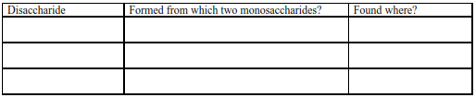

- Lipids include fats, waxes, oils, phospholipids, and steroids. What characteristic do all lipids
share?

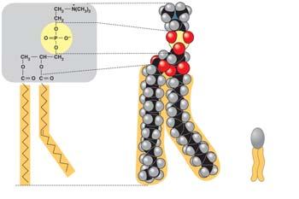
- Here is a figure that shows the structure of a phospholipid. Label the sketch to show the phosphate group, the glycerol, and the fatty acid chains. Also indicate the region that is hydrophobic and the region that is hydrophilic.

- Why is the “tail” hydrophobic?

- Label each of the levels of protein structure on this figure.

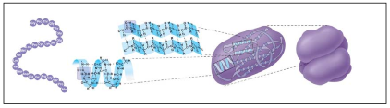

- Besides mutation, which changes the primary structure of a protein, protein structure can be changed by denaturation. Define denaturation.

- The flow of genetic information is from DNA to RNA to protein. Use this figure to explain the process. Label the nucleus, DNA, mRNA (all 3 pieces), ribosome, amino acids and protein.

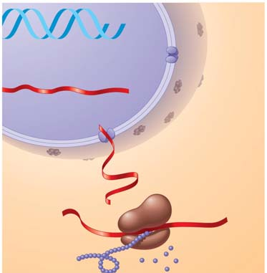

- What are the 3 parts of a nucleotide?

- Which four nitrogen bases are found in DNA?

- Which four are found in RNA?

Chapter 7: A Tour of the Cell

- A major difference between prokaryotic and eukaryotic cells is the location of their DNA. Describe this difference.

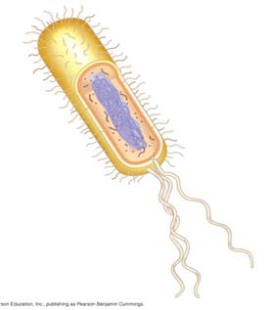
- On the sketch of a prokaryotic cell, label each of these features and give its function or description.
- cell wall
- plasma membrane
- bacterial chromosome
- nucleoid
- cytoplasm
- flagella

- Why are cells so small? Explain the relationship of surface area to volume.

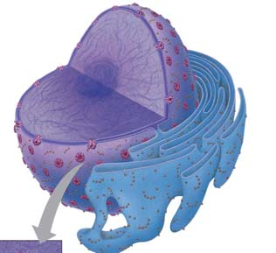
- In the figure to the right, label the nuclear envelope, nuclear pores, and pore complex.

- Found within the nucleus are the chromosomes. They are made of chromatin. What are the two components of chromatin?

- What is the function of ribosomes?

- List and describe three major functions of the smooth ER.

- The rough ER is studded with ribosomes. As proteins are synthesized, they are threaded into the lumen of the rough ER. Some of these proteins have carbohydrates attached to them in the ER to form glycoproteins. What does the ER then do with these secretory proteins?

- The transport vesicles formed from the rough ER fuse with the Golgi apparatus. Describe what happens to a transport vesicle and its contents when it arrives at the Golgi.

- There are many types of vacuoles. Briefly describe:

  - food vacuoles
  - contractile vacuoles
  - central vacuoles in plants

(give at least three functions/materials stored here)

- Mitochondria and chloroplasts are not considered part of the endomembrane system, although they are enclosed by membranes. Sketch a mitochondrion here and label its outer membrane, inner membrane, inner membrane space, cristae, matrix, and ribosomes.

- What is the function of the mitochondria?

- What is the function of the chloroplasts?

- Recall the relationship of structure to function. Why is the inner membrane of the mitochondria highly folded?

- On these diagrams of plant and animal cells, label each organelle and give a brief statement of its
function.

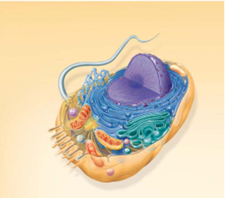

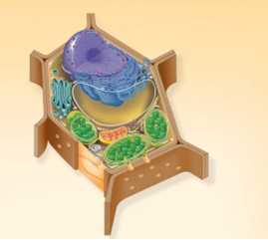

- What is the cytoskeleton?

- What are the three roles of the cytoskeleton?

- What are three functions of the cell wall?

- What is the composition of the cell wall?
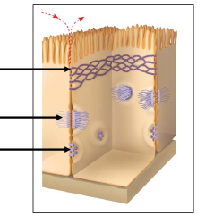

- This figure shows the three types of intercellular junctions seen in animal cells. Label each type and summarize its role.

Chapter 8: Membrane Structure and Function

- Describe the structure of the fluid mosaic model of the cell membrane.

- Membrane proteins are the mosaic part of the model. Describe each of the two main categories:
  - integral proteins
  - peripheral proteins

- Distinguish between channel proteins (channels) and carrier proteins (pumps).

- Are transport proteins specific?

- Define the following terms:

  - diffusion
  - concentration gradient
  - passive transport
  - osmosis
  - isotonic
  - hypertonic
  - hypotonic
  - plasmolysis

- Use as many words from the list above to describe why a carrot left on the counter overnight would become limp. Underline each word you use.

- Label the hypotonic solution, isotonic solution, and hypertonic solution. What is indicated by the blue arrows? Label them.

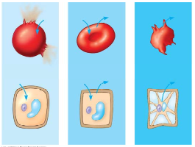

- On the diagram below, add these labels: facilitated diffusion with a carrier protein, facilitated diffusion with a channel protein, active transport with a carrier protein, simple diffusion. For each type of transport, give an example of a material that is moved in this manner.

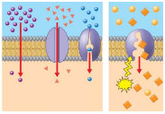

- Explain the concept of a concentration gradient.

Chapter 11: Cell Communication

- What is a signal transduction pathway?

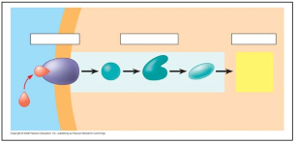
- A signal transduction pathway has three stages. Use Figure 11.6 to label the missing parts of the preview figure below, and then explain each step.
- Reception

- Transduction

- Response

Chapter 6: An Introduction to Metabolism

- There are two types of reactions in metabolic pathways: anabolic
a. Which reactions release energy?
b. Which reactions consume energy?
c. Which reactions build up larger molecules?
d. Which reactions break down molecules?
e. Which reactions are considered “uphill”?
f. What type of reaction is photosynthesis?
g. What type of reaction is cellular respiration?
h. Which reactions require enzymes to catalyze reactions?
3. Contrast kinetic energy with potential energy.

- What is free energy?
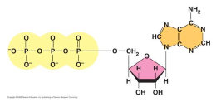
- Here is a molecule of ATP. Label it. Use an arrow to show which bond is likely to break.

- What is a catalyst?

- What is activation energy (E_{A})?

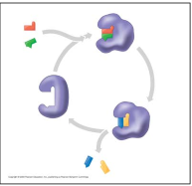
- Label this figure while you define each of the following terms:

  - enzyme
  - substrate
  - active site
  - products

- What is meant by induced fit? How is it shown in this figure?

- Study this figure from your book (Figure 8.22).

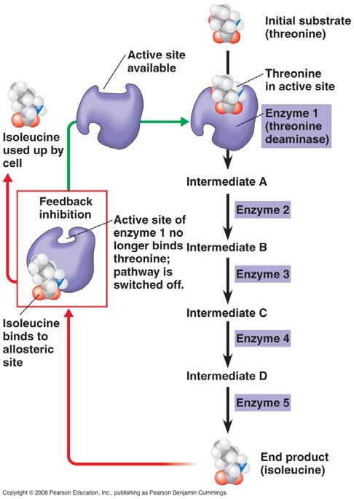
a. What is the substrate molecule to initiate this metabolic pathway?

b. What is the inhibitor molecule?

c. What type of inhibitor is it?

d. When does it have the most significant regulatory effect?

e. What is this type of metabolic control called?

Chapter 9: Cellular Respiration: Harvesting Chemical Energy
- Use Figure 9.2 to label the missing parts below.
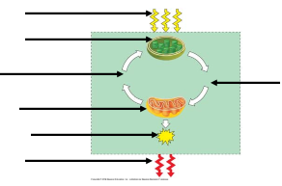

- Explain the difference between fermentation and cellular respiration.

- What is the difference between oxidation and reduction?

- Understanding the overall map of how cellular respiration works will make the details easier to learn. Use Figure 9.2 to label the missing information in the figure below.

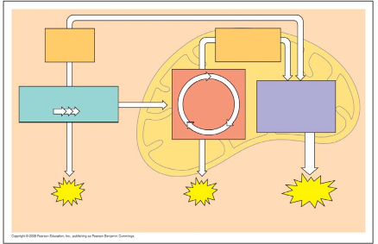
- The starting product of glycolysis is the six-carbon sugar ________________, and the ending product
is two ____________ carbon compounds termed ____________________.

- Use Figure 9.11 to help you answer the following summary questions about the citric acid cycle:

a. How many NADHs are formed?

b. How many total carbons are lost as pyruvate is oxidized?

c. The carbons are removed in d. How many FADH₂ have been formed?
molecules __________ __________ .

e. How many ATPs are formed?

- The two electron carrier molecules that feed electrons into the electron transport system are ________________ and __________________.

Figure 9.16 is a key to understanding the production of ATP in the mitochondria. In the figure below, label the following: mitochondrial matrix, intermembrane space, ATP Synthase, ADP, Phosphate, ATP. Then use one color to trace the flow of electrons and another color to show the flow of protons.

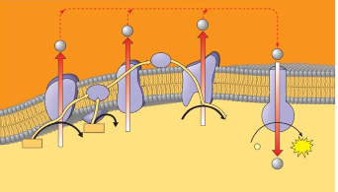

Chapter 10: Photosynthesis

- Define the terms autotroph and heterotroph.

- Label the following on the diagram: Stroma, thylakoid, grana, light reactions, calvin cycle. Identify the items that are cycled between the light reactions and the Calvin cycle (where the arrows are).

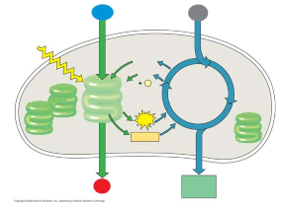

- What are the colors of the visible spectrum?

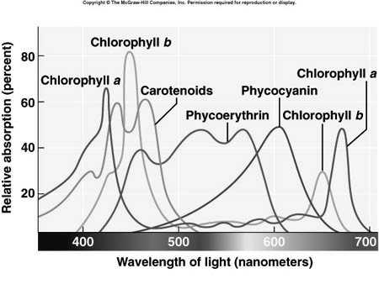
- Explain what this graph tells you about the color of light that is best for each of these photopigments: Chlorophyll a, Chlorophyll b and Carotenoids.

- Why is green light the worst color to use for a plant? What evidence does the graph provide?

- Label the following on this diagram of the light reactions: Photosystem I, Photosystem II, Water, Antennna pigments, ATP, NADPH_{2,} Oxygen.

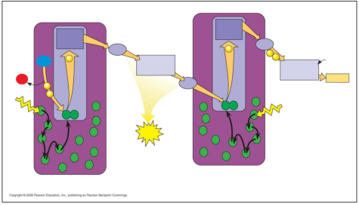

- Define Chemiosmosis.

- Define Carbon Fixation. Identify the source of the carbon used.

- Explain what is meant by a C 3 plant. Give a few examples of plants of this type.

- Explain what is meant by a C₄ plant. Give a few examples of plants of this type.

- What environmental condition are C4 and CAM plants adapting to?

Chapter 12: The Cell Cycle

- What are the three key roles of cell division? State each role, and give an example.

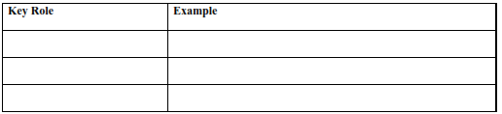

- What is meant by the cell cycle?

- What is the meaning of genome? Compare your genome to that of a prokaryotic cell.

- How many chromosomes are in a human somatic cell?

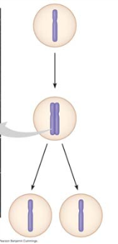
- What is a gamete?

- Study Figure 12.4. Label the figure below, and summarize what occurs at the DNA level in each stage.

- What is mitosis? How is it different from cytokinesis?

- What occurs in meiosis? How is the chromosome number of daughter cells different?

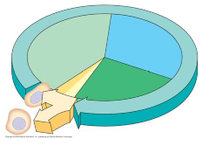
- Label each of the parts of the cell cycle listed below, and give a brief explanation of what
happens in each phase.

G1

S

G2

M

- What is a cell cycle checkpoint?

Chapter 13: Meiosis and Sexual Life Cycles

- Distinguish between sex chromosomes and autosomes. How many of each are found in human cells?

- Explain what is meant by homologous chromosomes.

- The muscle cells of a dog have 78 chromosomes. Fill in the correct chromosome number in a:
bone cell_______ sperm_______ haploid cell_______ somatic cell_______ zygote_______

- In the cell at right, the chromosomes are shaded in two colors to represent the parent of origin.
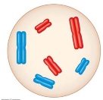
On this sketch, label the following:

- sister chromatids
- homologous chromosomes
- centromere
- replicated chromosome
- maternal chromosomes

- What is the purpose of meiosis?

- To check that you have the big picture, here are some quick review questions.
- What happens to chromosome number in meiosis?

- During which division is the chromosome number reduced?

- What is the purpose of meiosis?

- How many times does the cell divide in meiosis?

- How many times do the chromosomes duplicate?

- How many daughter cells are formed?

- What is the chromosome number?

- What are homologs (homologous chromosomes)?

- What is crossing over?

- An important idea for you to understand is that new alleles arise by changes in the DNA or mutation, but genetic diversity occurs when the deck that is dealt is simply reshuffled. So, there are three ways that sexually reproducing organisms “shuffle the deck.” They are listed below. Each of these increases diversity.

- independent assortment of chromosomes

- crossing over

- random fertilization

Chapter 14: Mendel and the Gene Idea

- Define the following terms. Then, consider your own family. Which generation would your Mom’s grandparents be? Your Mom? You?

P generation

F1 generation

F2 generation

- Mendel’s model consists of four concepts. Describe each concept in the appropriate space below. Indicate which of the concepts can be observed during meiosis by placing an asterisk by the concept.

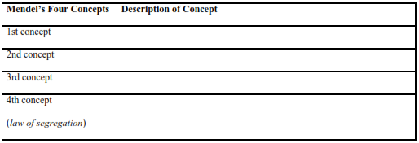

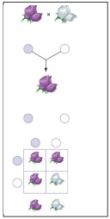
- Using Figure 14.5 as your guide, provide the missing notations for the figure below.

- What is the F₂ phenotypic and genotypic ratio?

- Which generation is completely heterozygous?

- Which generation has both heterozygous and homozygous offspring?

- In pea plants, T is the allele for tall plants, while t is the allele for dwarf plants. If you have a tall plant, demonstrate with a test cross how it could be determined if the plant is homozygous tall or heterozygous tall.

- Explain how incomplete dominance is different from complete dominance, and give an example of incomplete dominance.

- Compare and contrast codominance with incomplete dominance.

- Explain what is meant when a gene is said to have multiple alleles.

Chapter 15: The Chromosomal Basis of Inheritance

- Explain the law of segregation.

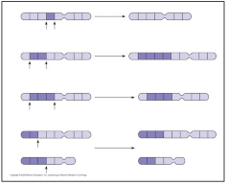
- Chromosome structure can be altered in several ways. Label each type of alteration shown in this figure, and explain what occurs.

- deletion
- duplication
- inversion
- translocation

Chapter 16: The Molecular Basis of Inheritance

- What are the two chemical components of chromosomes?

- Explain the base-pairing rule.

- What is the semiconservative model of replication?

- Distinguish between the leading and the lagging strands during DNA replication.

- What is the direction of synthesis of the new strand?

- What are Okazaki fragments?

- Label the following figures. Include 3' and 5' strands, RNA primer, primase, , helicase, leading strand, lagging strand, DNA polymerase (all of them), DNA ligase, parental DNA, and new DNA.

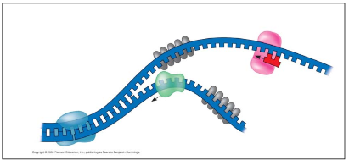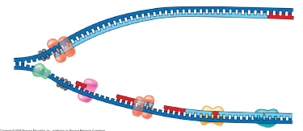

Chapter 17: From Gene to Protein

- What are the monomers of DNA and RNA? Of proteins?

- Complete the following table to summarize each process.

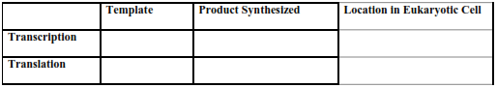

- So, the language of DNA is a triplet code. How many unique triplets exist? ______________

- Here is a short DNA template. Below it, assemble the complementary mRNA strand.

3'A C G A C C A G T A A A 5'

- Explain the concept of reading frame.

- Let’s now take a closer look at initiation. Read the paragraph titled “RNA Polymerase Binding and Initiation of Transcription” carefully. List three important facts about the promoter here.
(1)

(2)

(3)

- Distinguish between introns and exons. Perhaps it will help to remember this: Exons are
expressed.

- What is the consequence of alternative splicing of identical mRNA transcripts?

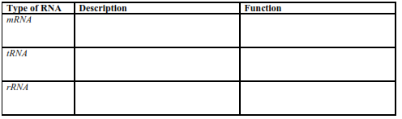

- Define a mutation in terms of molecular genetics.

- Define point mutations.

- What are frameshift mutations?

Chapter 19: Regulation of Gene Expression

- All genes are not “on” all the time. Using the metabolic needs of E. coli, explain why not.

- Feedback inhibition is a recurring mechanism throughout biological systems. In the case of E. coli regulating tryptophan synthesis, is it positive or negative inhibition? Explain your choice.

- List the three components of an operon, and explain the role of each one.

- Match the numbered components on this sketch of the lac operon with the terms at right
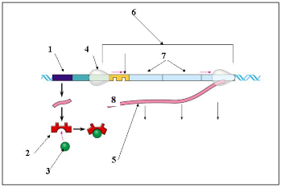
- ______Operon genes
- ______Operon RNA polymerase
- ______mRNA
- ______Repressor protein
- ______Operator
- ______Repressor
- ______Regulatory gene
- ______Inducer

- Even though all cells of an organism have the same genes, there is differential gene expression. What does this mean?

- It is now known that much of the RNA that is transcribed is not translated into protein. these RNAs are called noncoding RNAs. Read carefully to discern a crucial role played by these RNAs. What is this role?

